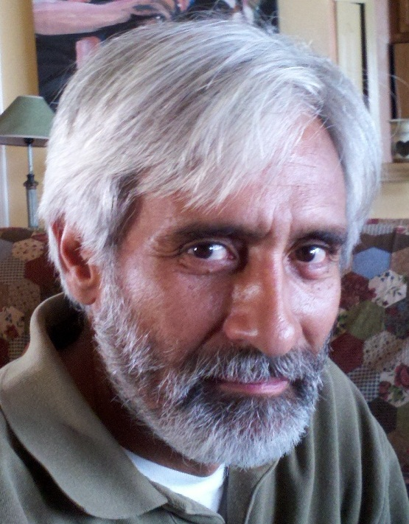
Claudio Avendano
Civilsocialmedia.com

History and evolution of our direct open collaborative business administration platform.

1968 Atlanta, Tailor’s Apprentice
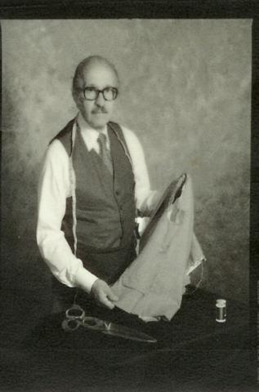
My grandfather and father were tailors. I began working as an apprentice with my father when I was thirteen years old. I then worked with several mens stores at Lenox Square, Parks Chambers and then Cuzzens. We were the only tailors in Atlanta that made custom clothing on premises.

At nineteen I opened a shop in the back of a men’s store at Phipps Plaza. We provided alteration services to twelve stores at Phipps, Perimeter, and Lenox.

The shop at Phipps did well, we had three employees and provided alterations for 12 stores at Phipps, Perimeter and Lenox. One of our clients was Guffeys of Atlanta. I provided contract alteration services to them, until they hired me as head tailor, I worked with them until 1978.

1977 Buckhead Atlanta, 3538 Roswell Road
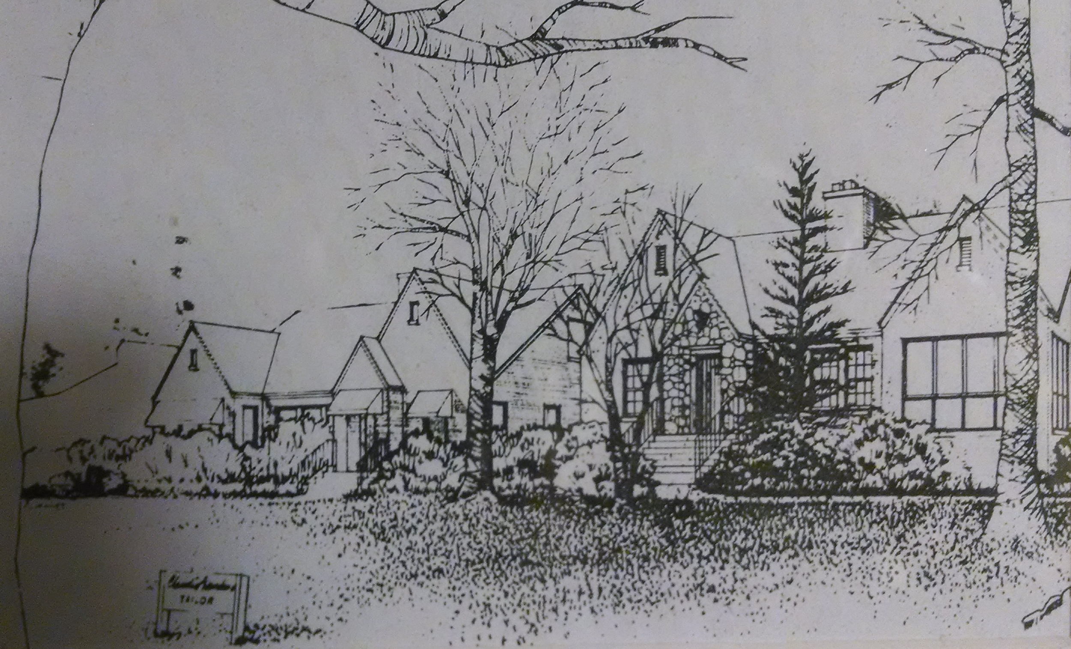
Purchased my first property 3538 Roswell Road. I opened my tailor shop there and converted the property into a triplex.
Ten years later I will sell this property and move my shop to Trinity Avenue.
I will purchase 4 buildings and build some of the first lofts in Atlanta.

Along with the Trinity property came the Youthform brazier company, that was about to shut down. Operated by Wills Dunn and one sewing operator, yet it had cutting tables and over 20 sewing machines that I had hoped to convert that into a cut, make, and trim shop making custom men’s clothing in Atlanta.

1979 Atlanta, Buckhead, 2813 Peachtree Road

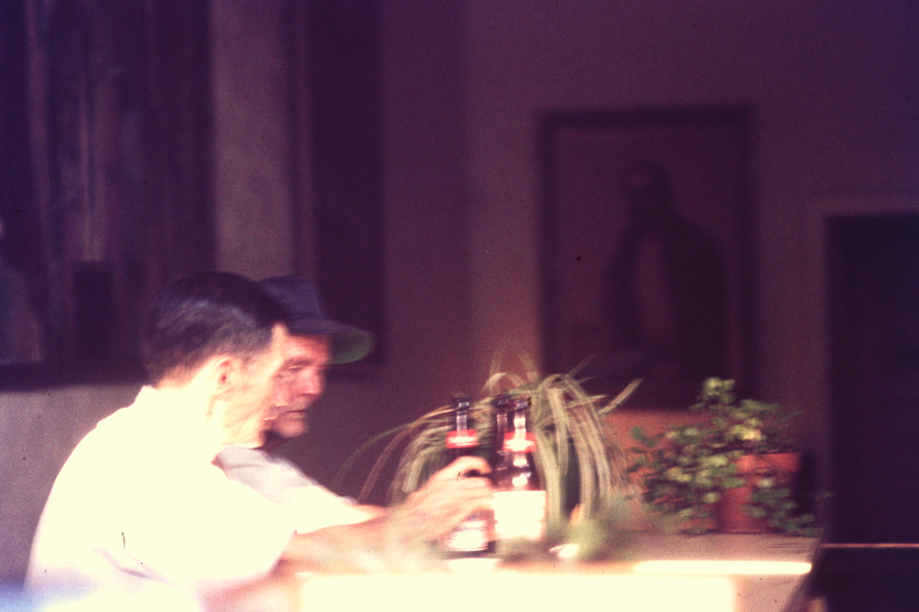
Purchased an old beer joint, it was called the "Briar Patch" at 2813 Peachtree Road. The city had condemned the building. It was converted into a small pub called "Claudio's." Andrew Young spoke here during his 1981 Mayoral Campaign. Notorious for it's cold PBR in long neck bottles, juke box, a chicken plate as well as the hangout of the outlaws.

Three years later I sold it to Mike Nelson, and Clay Harper and this became the first Fellini's Pizza.

1980 Atlanta Downtown Trinity Avenue

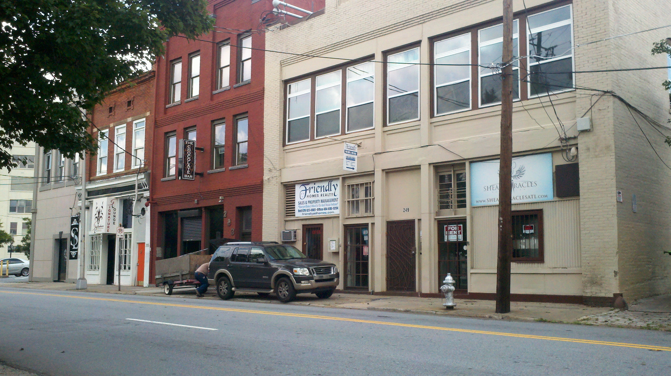
Form the sale of the pub, and later the house on Roswell Road house I purchase a total of five turn of the century buildings in downtown Atlanta. The corner building had been the Youtform brazier company, I had hoped to convert this into a cut make and trim shop, producing men’s custom clothing.
The remainder of the properties were converted into commercial/residential lofts. This is before Lofts became known as a way to live in Atlanta.
After about 18 years I will sell these and build a shop in Chile where tailors are easier to find and the labor is more affordable.

2000 Moved the Tailor Shop to Chile

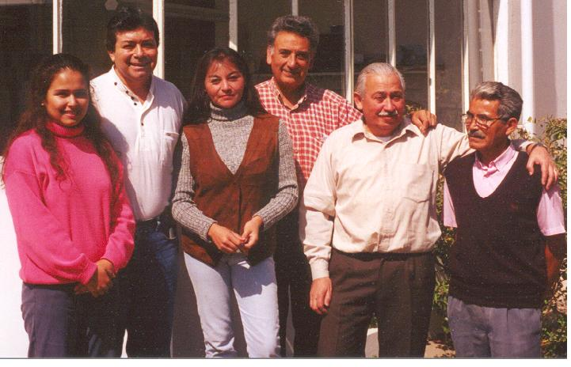
After several test runs I purchased a commercial house just outside of Vina Del Mar, Chile and started up a cut make and trim shop.
I hired tailors, and showed them how to make hand made garments for a U.S. client base. I began developing database driven software that could track client orders.
We transferred measurements and design into a plotted pattern for each client at our retail store in Midtown Atlanta.
My eldest son applied this concept to the Wharton entrepreneur prize and won. We began selling clothing to his start up in Philadelphia.

2001 Purchased 80 hectares outside of Punta Choros

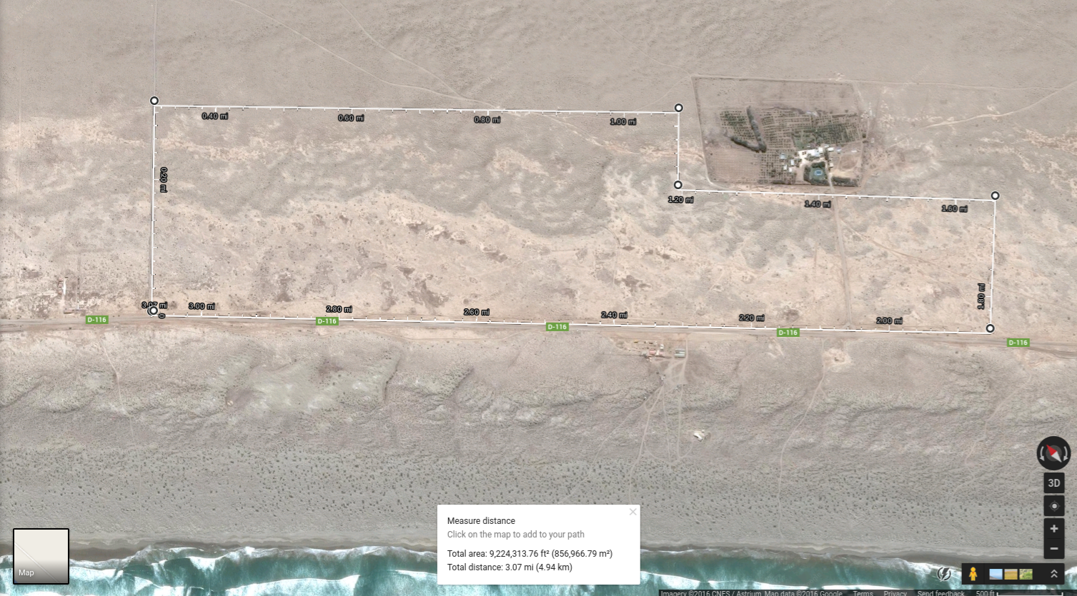
With some of the sale of the properties on Trinity Avenue, I purchased 80 hectares of land between the towns of Punta Choros and Los Choros in Chile. I subdivided the land in Chile into 161 one acre vacation lots.

2004 Atlanta Pershing Point Store
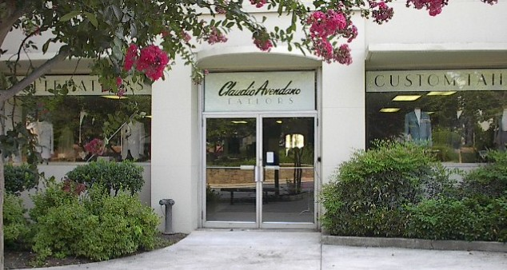
Leased the first floor of this West Peachtree Road address, and built a retail outlet for the sale of the clothing we made in Chile.
Before we opened our landlord was foreclosed upon and lost the property. All tenants of the building were required to vacate.
The lender that ended up with the property was an old client of mine, and we were permitted to stay as the only tenant (rent free) until the property was sold and remodeled.
I try to restart after this with a venture in Philadelphia but that will last only two more years. The 2008 recession will eventually force us to close tailoring operations.

2008 Political Involvement - Metroecho.com
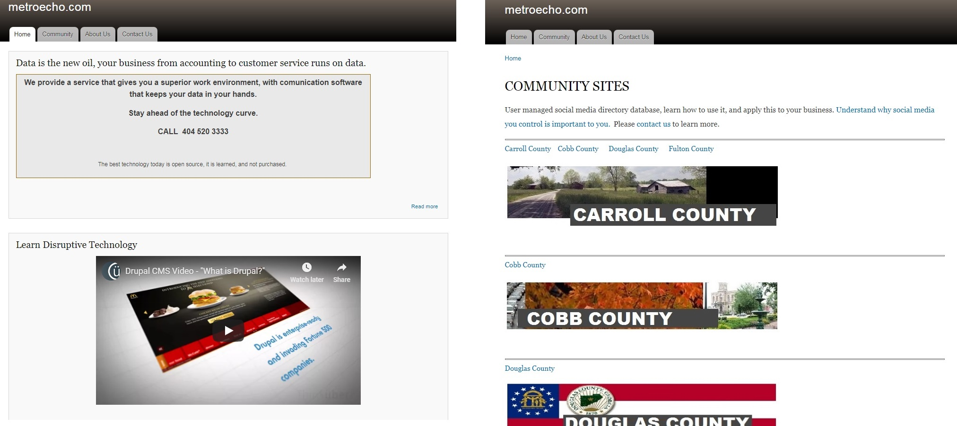
The 2007- 2008 financial crisis was the nail in the coffin for the shop in Chile.
On April 15 2008. My son and returned to Villa Rica, Georgia, just west of Atlanta.
I became involved with the dominant political party, and would learn that politics was a group of people looking to take money out of the pockets of other people.
I recognized the political importance of database social media technology, and tried to introduce a community based platform, that would be user administered. Metroecho.com

2014 Vendors Market, Libertyhaus
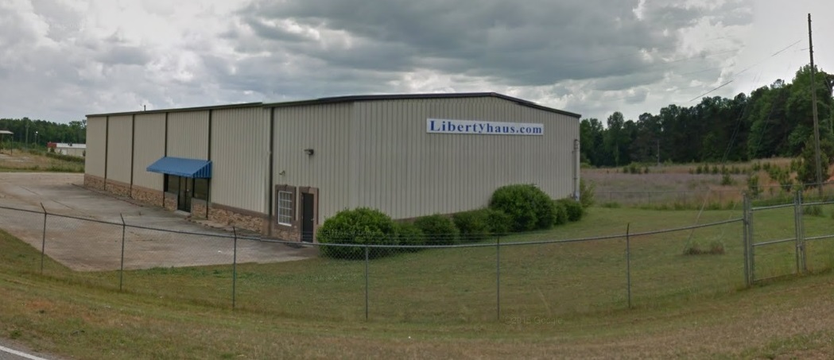
I purchased 155 Liberty Road, in Villa Rica Georgia. Two acres just off I-20, 30 minutes west of Atlanta. The property was owner financed, here I planned to build a marketplace with the aid of open source social media software.
Vendors with good business concepts were permitted to set up sales venues without upfront deposits. They would have the ability to collaborate through a social media app in order to promote sales, and manage the venue.
Those that came to participate in the project were unable to sustain business agreements which lead to a re-start as a storage business with a re-opened tailor shop at the location.

October 2015 storeitorsellit.com - Superior storage solutions
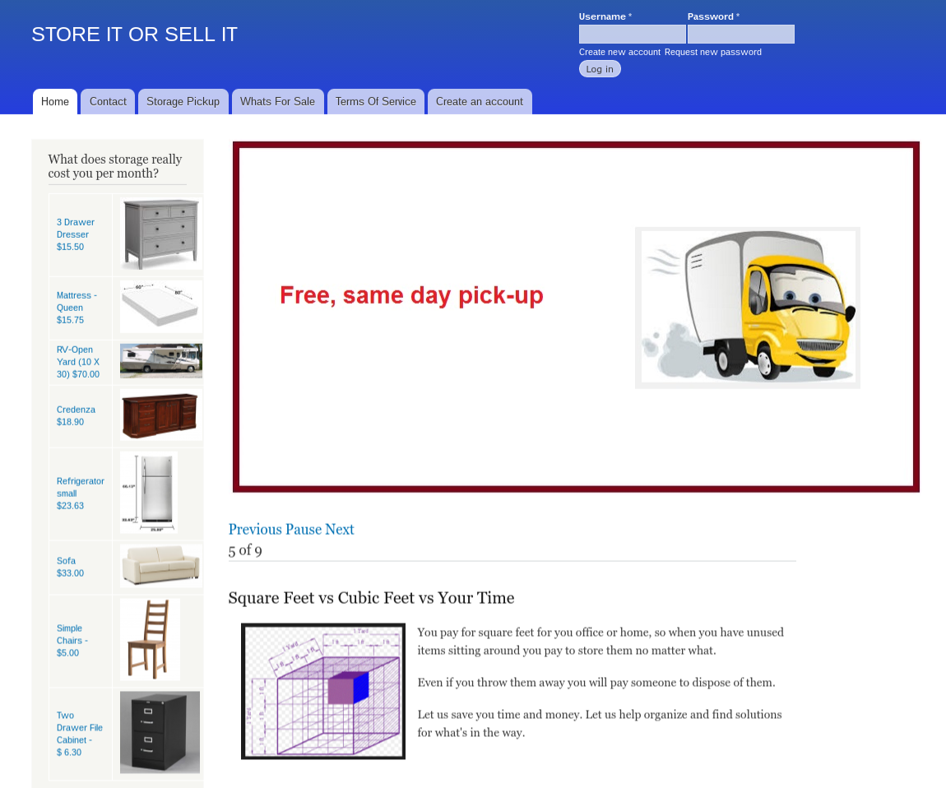
Re-structured the Libertyhaus concept and opened... Storeitorsellit.com

After the Libertyhaus experience I became concerned that there may be a local organization dedicated to putting me out of business. Maybe I should not have gotten involved in politics, I just wanted to do the right thing.
I heard the expression once, “Politicians are like pigs and you don’t get between the pigs and the troth at feeding time”.
I built this storage solution to suit the property I had purchase on Liberty Road. It would focus on storage clients in the Atlanta metropolitan area.

Similar to Clutter and Makespace, we have incorporated this, and other past aspects into our latest web platform, which is designed for collaborative business administration.

2016 Bankruptcy and moved to Pennsylvania

This is not your typical bankruptcy, a situation that draws back to when I became involved in politics, something we might expect out of Putin's Russia, and not of the courts in this country.

This is the long version, this is the quick version....

I had no debt, and over 2 million in assets, In 2014, I purchased an owner financed building in Villa Rica, Ga. from a local fella.
Locals interfered with my business, and I fell behind on my mortgage.
In order to keep my property, not give the building back to the local fella, or loose my business, I went into bankruptcy.
I paid all I was required to pay, and on time, to the creditors, and the court. My attorney failed to file documentation, and did not advise me. The guy that sold me the property pushed the Court to take possession of everything I owned.
I lost the property I had purchased from him, my business assets, income, and other local real estate I owned was sold for almost nothing, then locals threatened my son, so I moved out of town.

Years later, I am still in bankruptcy while a team of lawyers bill my estate, and continue to work hard to make over 2 million dollars vanish into administrative fees.

Since they took everything I had, and left with no money to hire lawyers to fight this absurd situation. In addition Bankruptcy court is noted for this form of abuse, and there is no political will to correct the problem.

After a few years, I gave up trying to save any of my estate from this Court, and its Trustee. But, I hope presenting my situation to you will prevent anyone else who is property rich, inadvertently stepping into this hazard.

2020 A New Web Platform, Tailor Shop, and Real Estate Renovations

I am starting over, I moved to Amish country, and opened a tailor shop. I hope this resume of mine will entice you to do business with me as I look for partners in our new web platform, as a tailoring client, or with assistance with finding properties we can renovate through lease option mechanisms....

Through our web platform for direct open collaborative business administration.

Civilsocialmedia.com

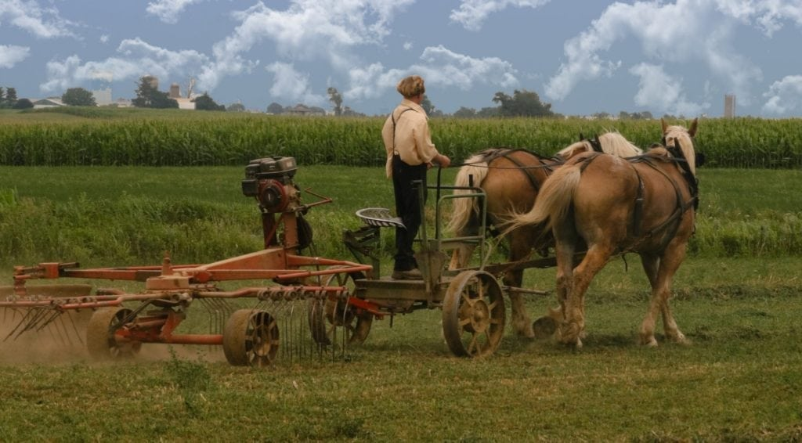

Claudio Avendano
8 West Main Street
Strasburg, Pennsylvania - 17579
717 301 8988

